Name: Rajesh Chitikela

Email: rajeshchitikala888@gmail.com

Q1. Find out the mail servers of the following domains?

1. I used the following command for this,
2. Nslookup
3. Set type=mx
4. Ibm.com

And the following results are,

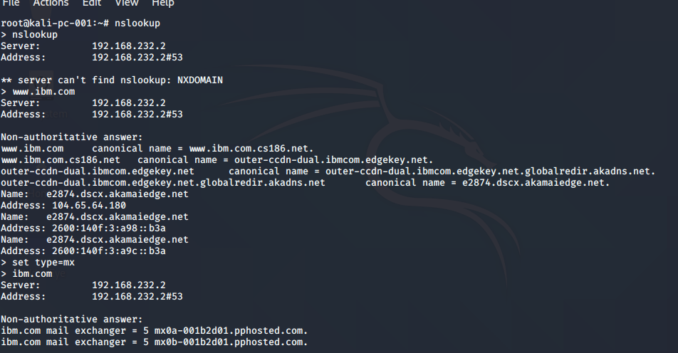

For wipro.com,

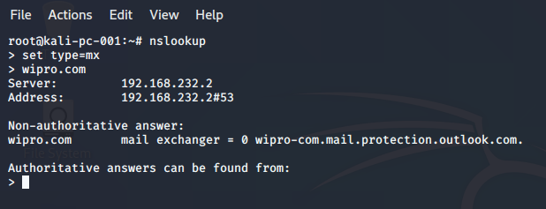

2Q. Find the locations where the emails servers are hosted?

1. 1) IBM.com
2. Here, for this question I used a online ip tracker

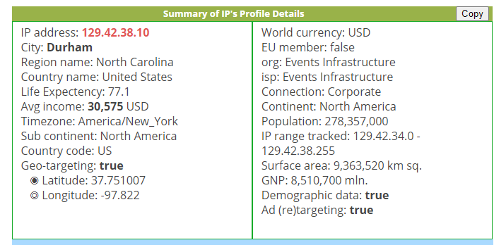

2) wipro.com

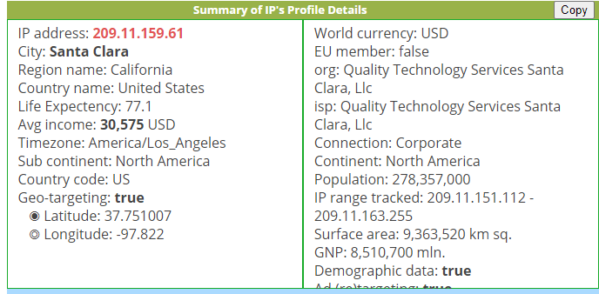

3Q. Scan and find out port numbers open on 203.163.246.23 ?

1. I used the command nmap –pn –p1-65535 203.163.246.23

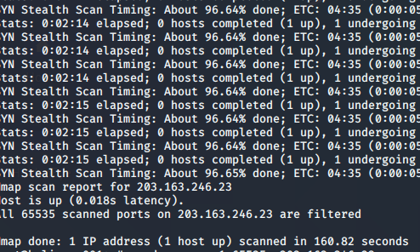

All ports are filtered here.

4). Install nessus in a vm and scan for laptop/desktop for cve?

I have installed it but it is taking too much time to plugins to compile,, as now time is not permitting to scan I am uoloading till what I did for now.